- Start zookeeper

bin\windows\zookeeper-server-start.bat config\zookeeper.properties

- Start Kafka Broker

bin\windows\kafka-server-start.bat config\server.properties

- Create Kafka Topic

bin\windows\kafka-topics.bat --create --topic group-demo --bootstrap-server localhost:9092 --partitions 3 --replication-factor 1

- Start Consumer 1 and Consumer 2 using the same group

bin\windows\kafka-console-consumer.bat --topic group-demo --from-beginning --bootstrap-server localhost:9092 --group demo-group

… and in a different terminal

bin\windows\kafka-console-consumer.bat --topic group-demo --from-beginning --bootstrap-server localhost:9092 --group demo-group

- Start Kafka Producer

bin\windows\kafka-console-producer.bat --topic group-demo --bootstrap-server localhost:9092

>hello
>this is a test
>bye

Only one user receives all the messages. If consumers would not have the --group demo-group, all users would have received all messages.

- Producer with keys

bin\windows\kafka-console-producer.bat --topic group-demo --bootstrap-server localhost:9092 --property "parse.key=true" --property "key.separator=:"

>user1:orange
>user2:apple

Each message is received by a different user

- Monitoring
  - Describe topic
bin\windows\kafka-topics.bat --describe --topic group-demo --bootstrap-server localhost:9092

  - List Consumer Groups
bin\windows\kafka-consumer-groups.bat --bootstrap-server localhost:9092 –list

  - Describe Consumer Group
bin\windows\kafka-consumer-groups.bat --bootstrap-server localhost:9092 --describe --group demo-group

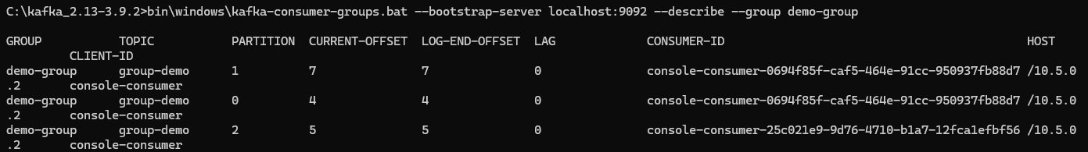

- Retention Demo

If I restart one consumer (user1) with

bin\windows\kafka-console-consumer.bat --topic group-demo --from-beginning --bootstrap-server localhost:9092

I receive all previous messages from both users. It first appears old messages from user 2 chronologically and then the old messages from user 1 chronologically.

- Offset Demo
bin\windows\kafka-console-consumer.bat --topic group-demo --bootstrap-server localhost:9092
only new messages appear
bin\windows\kafka-console-consumer.bat --topic group-demo --from-beginning --bootstrap-server localhost:9092
all previous messages appear

